April 6, 2020 | Weekly Economic Update
Presented by <<Advisor Name>>

Market Performance
as of market close, April 3, 2020

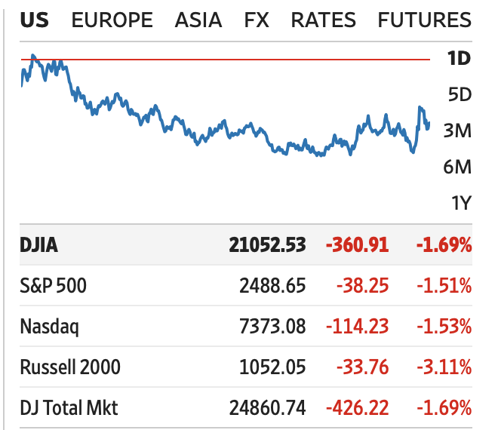
Source: Wall Street Journal

Wall Street Update
Stock-index futures rose sharply Sunday night as investors appeared eager to focus on a glimmer of optimism coming out of the White House about the potential for stabilization of the rapid spread of the worst viral outbreak in generations.
Continue Reading
Madrona Venture Group CEO Steve Singh discussed how a group of individuals banded to raise $30 million to support Seattle charities actively helping people hurt by the pandemic.
Continue Reading

Stocks Entering Period of Seasonal Strength
Kansas City Southern Corp. (NYSE:KSU)
US Ecology Inc (NASD:ECOL)
Ribbon Communications Inc. (NASD:RBBN)
Facebook, Inc. (NASD:FB)
Cable One, Inc. (NYSE:CABO)
Source: Equity Clock

On the Minds of Investors
The global oil market is experiencing a massive demand shock, with demand for transportation fuels sitting in the crosshairs of the coronacrisis. At the same time, major oil producers have engaged in a war for oil market share, resulting in a sizable supply shock. The impact of these simultaneous shocks on oil prices, OPEC+, the oil industry, and credit and financial markets more broadly are Top of Mind.
Continue Reading
International Market
Could COVID-19 permanently change how the global economy works?
Continue Reading

China promises not to restrict exports of medical supplies. Commerce Ministry says it remembers the ‘helping hand’ other countries gave China and will not restrict the sale of masks, gowns and other vital equipment.
Continue Reading

The Week Ahead | Key Economic Data
Monday: Consumer Inflation Expectations
Tuesday: JOLTs (Job Openings and Labor Turnover) Update
Wednesday: FOMC (Federal Open Market Committee) Minutes
Thursday: Weekly Jobless Claims
Friday: Consumer Price Index Update

(Sources - TradingEconomics.com and MarketWatch.com)

Quote of the Week
“The economic repercussions of a stock market crash depend less on the severity of the crash itself than on the response of economic policymakers, particularly central bankers.”
-Ben Bernanke, American economist and former Chair of the Federal Reserve

Last Week in Review
Jobless claims at 6,648k
Unemployment at 4.4%
Consumer confidence at 120.0
Source: Wall Street Journal

<<Advisor Name>> | <<Firm Name>>
<<Firm Address>>
<<Phone>>, <<Email>>. <<Website>>

_________________
This material was compiled by The Leaders Group, Inc. and is not represented as investment, tax, or legal advice or guidance. The information provided and sources therein are believed to be accurate. Please consult your investment, tax, or legal consultants for information as it relates to your personal circumstances.

Investing involves risk and past performance is no guarantee of future results. The return and principal value of investments will fluctuate as market conditions change. When sold, investments may be worth more or less than their original cost.

